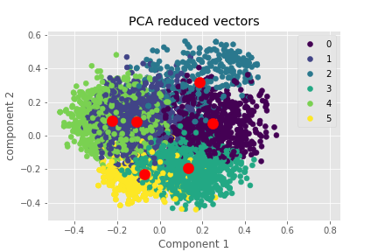**PCA:  Data Scientist and Statisticians are Neighbors**

Software Engineer Data Analyst Statistician

Data Scientist Data Engineer Database Administrator

